NM PROJECT REPORT

HR MANAGEMENT

1 INTRODUCTION

* 1. Overview Human resources (HR) is the division of the business responsible for finding, screening, recruiting and training job applications. by using the salesforce we make the exiting app more efficient for the HR team we create custom object and relationships to store access the data more efficiently.
  2. Purpose The over all purpose of the human resources(HR) is to ensure that the organization is able to achieve success through people. By using this salesforce app we can easily access the data of the employees for the HR team more efficient and we create a better relationship for the human capital(employees)and human resources(HR).

2 Problem Definition & Design Thinking

* 1. Empathy map

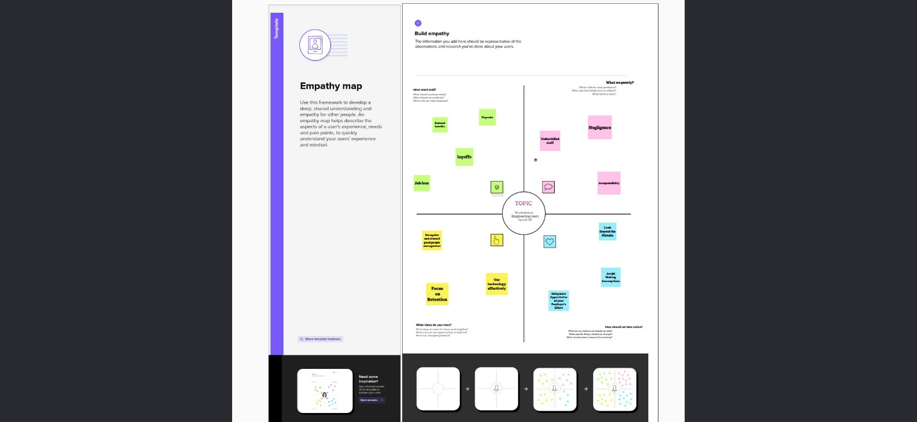

2.2 Ideation & Brainstorming map

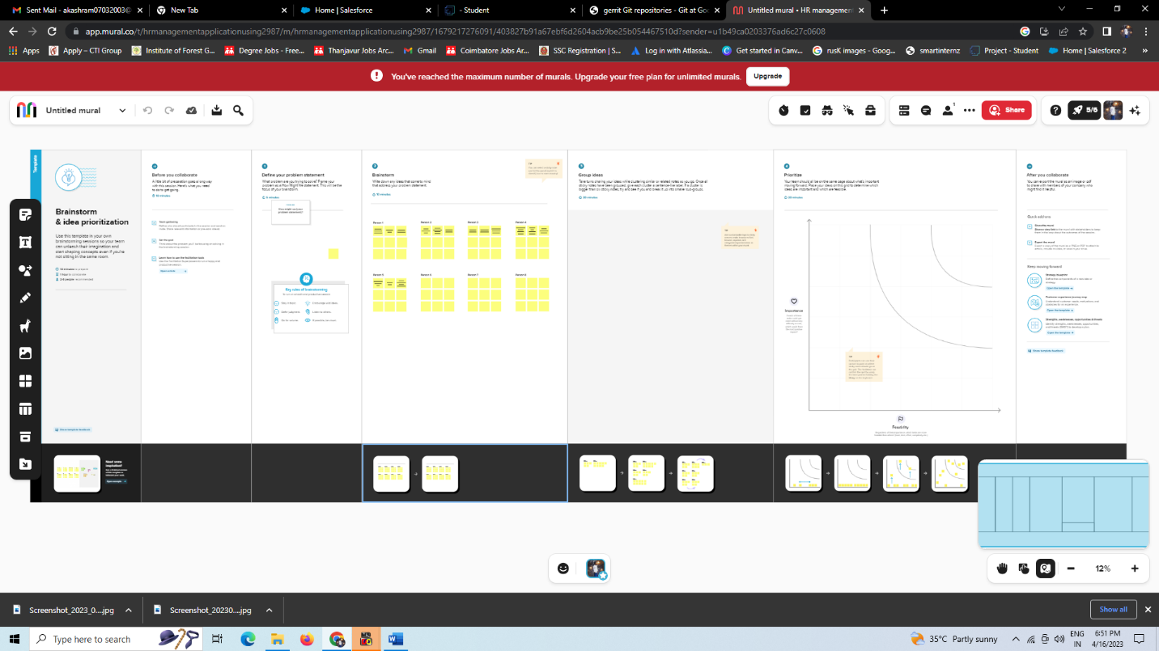

3 RESULTS AND TABULATION

* 1. DATA MODEL

|  |  |  |  |
| --- | --- | --- | --- |
| CUSTOMER  RELATED QUERIES | GRAPHICAL  BOXES | EMPOTHY MAP  AND RELATED | NO OF BOXES FILLED IN  IDEATION AND  BRAINSTORMING |
| 1.LIST IN THE  BRAIN STORM  AND EMPOTHY  MAP SESSION | DONE SUCESSFULLY WITH  NECESSORY  POINTS | COMPLETED  WITH  ESSENTAIL  ITEM | 15 BOXES  FILLED WITH  NECESSARY  ITEMS |

4 Activity and screenshots :

Milestone 1:

Creating developer Account:

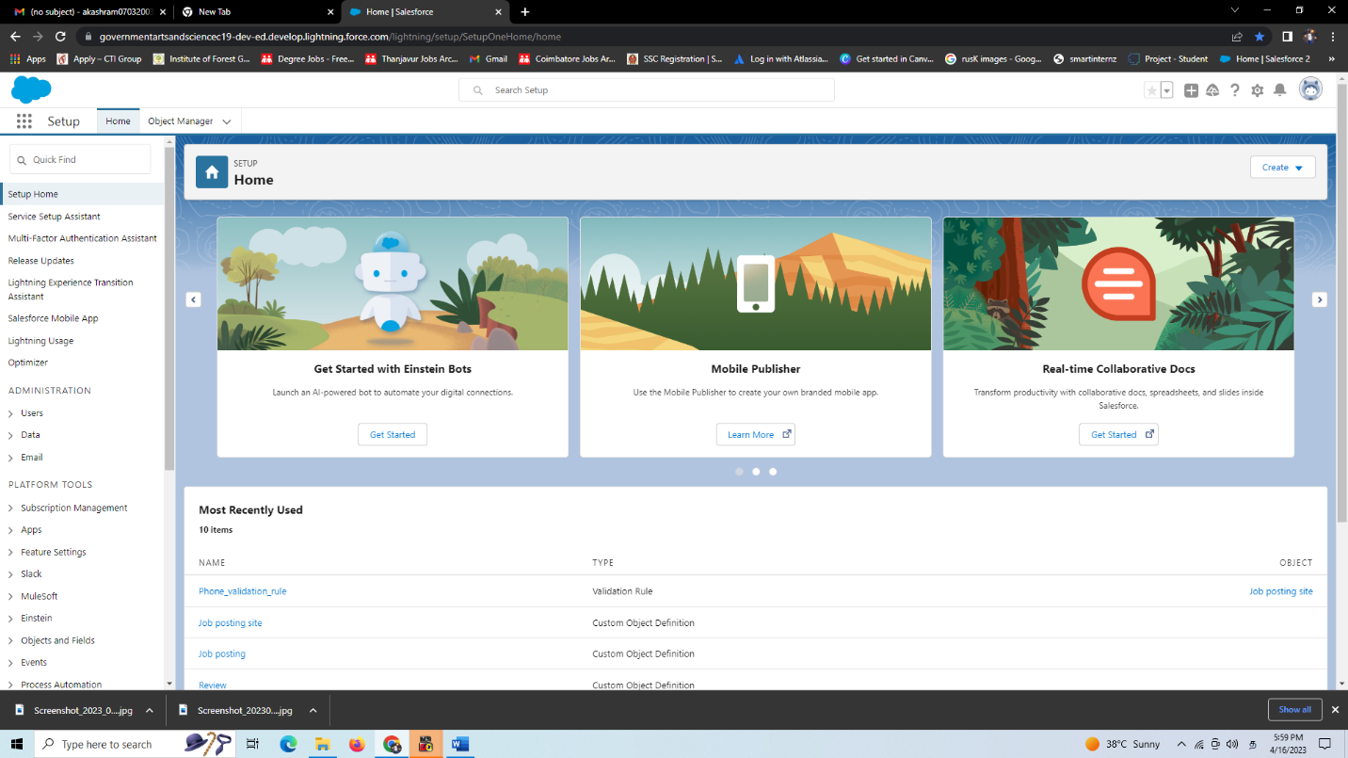

Milestone 2

Package installation

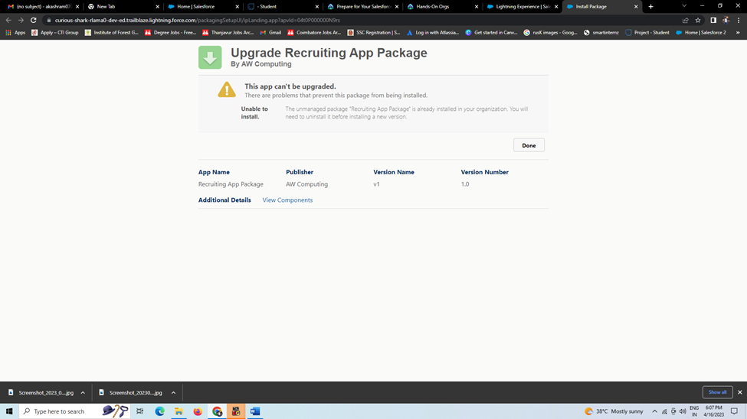

Milestone 3:

Creating a custom object for Job posting site

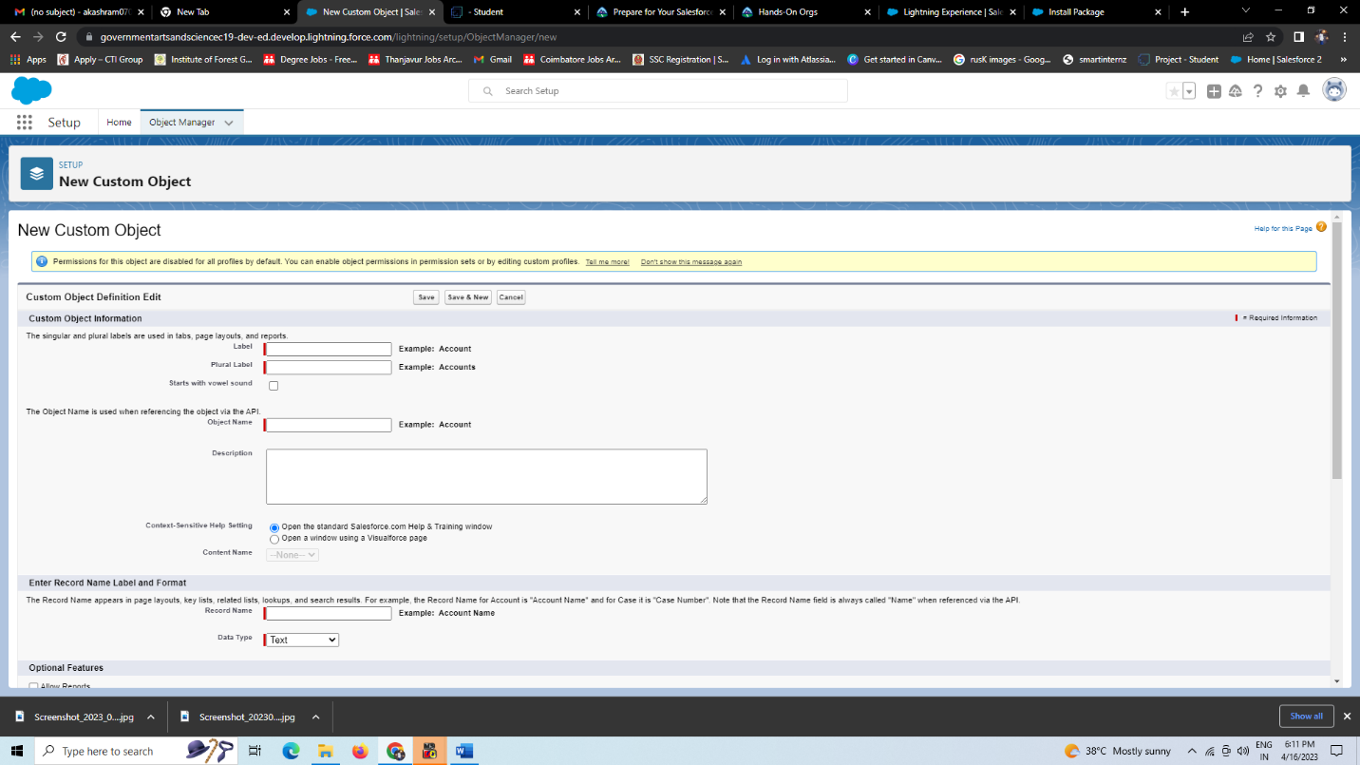

Milestone 4 :

Creating a tabs:

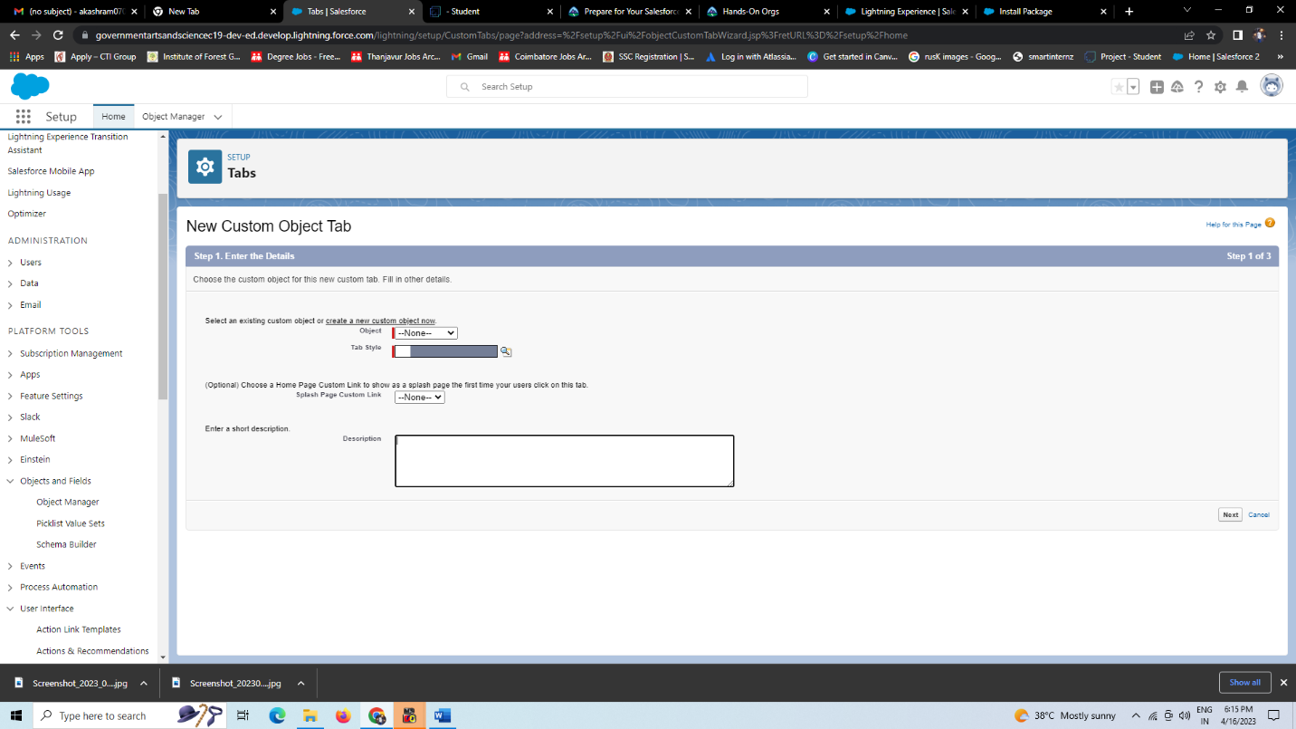

Milestone 5:

Create a new fields for job posting:

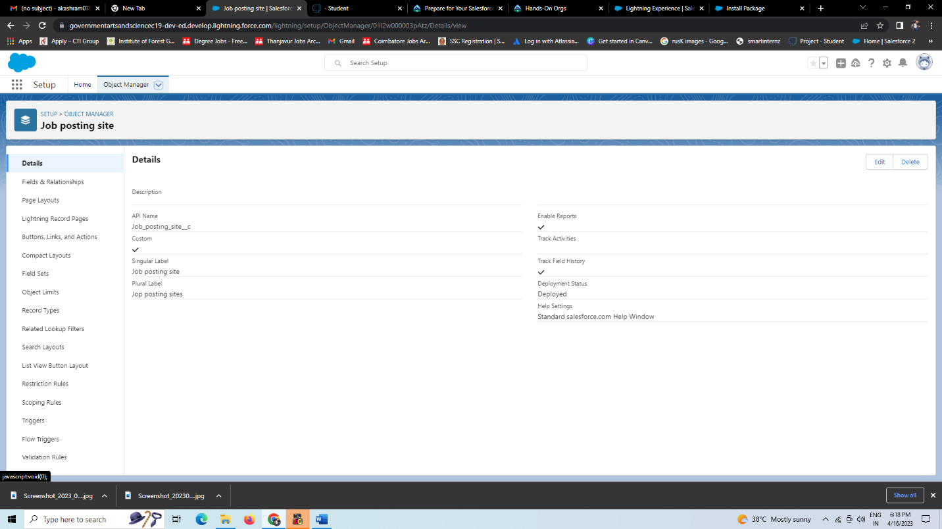

Milestone 6 :

Creating junction object:

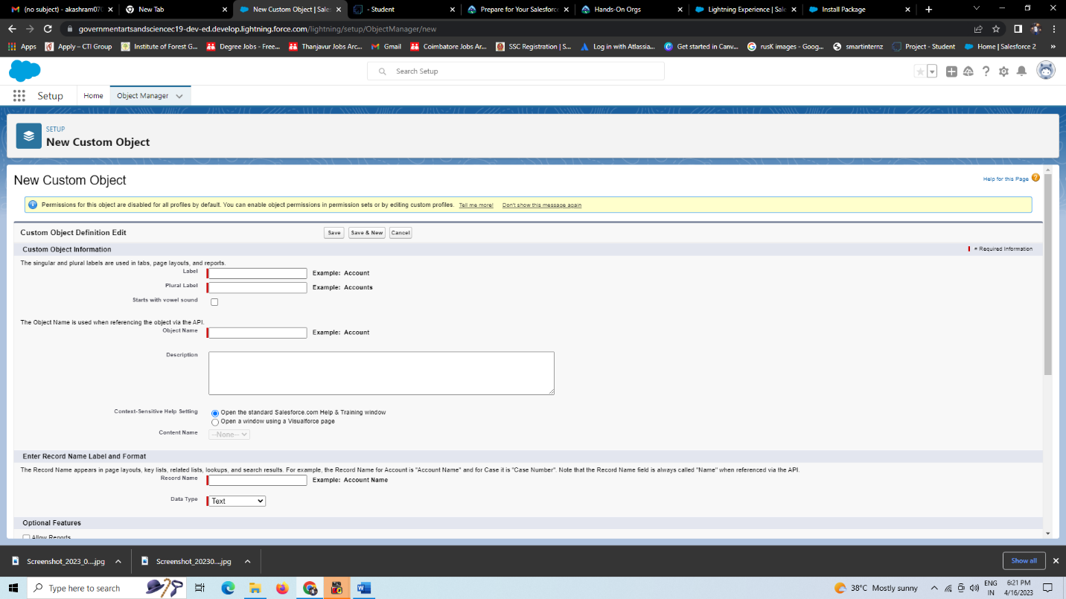

Milestone 7:Page layout:

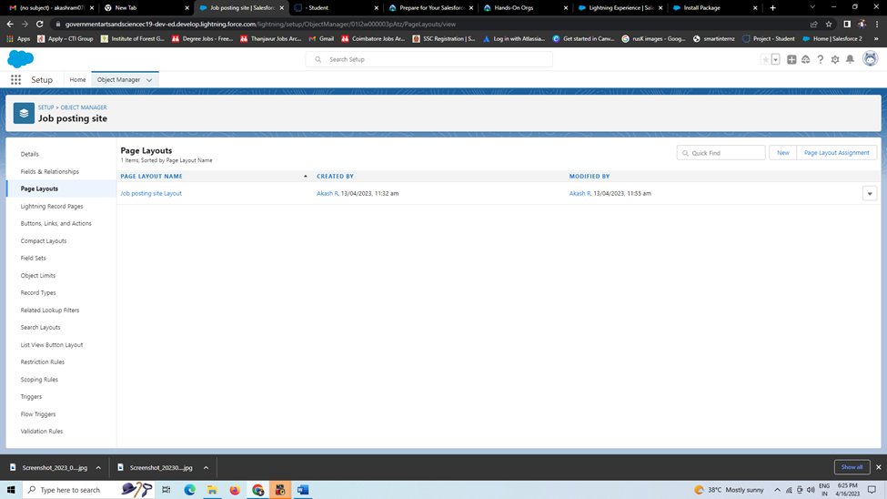

Milestone 8:

Creating a Validation rule :

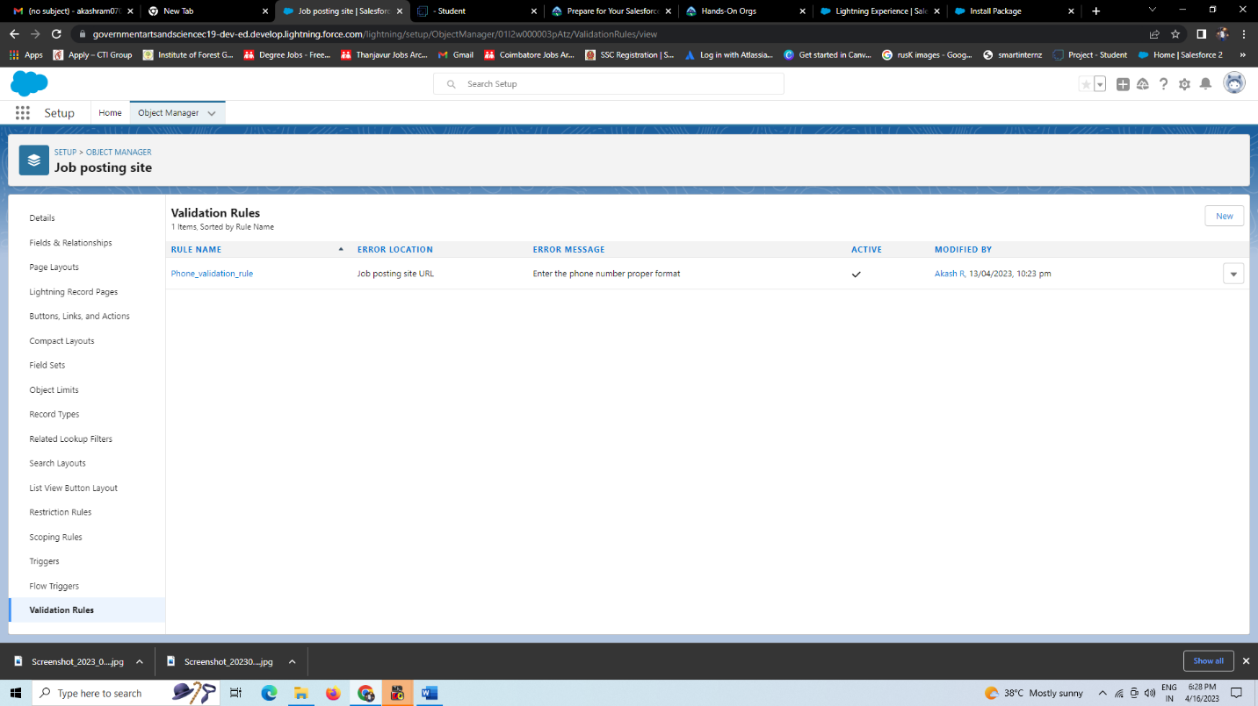

Milestone 9:

Creating a profile :

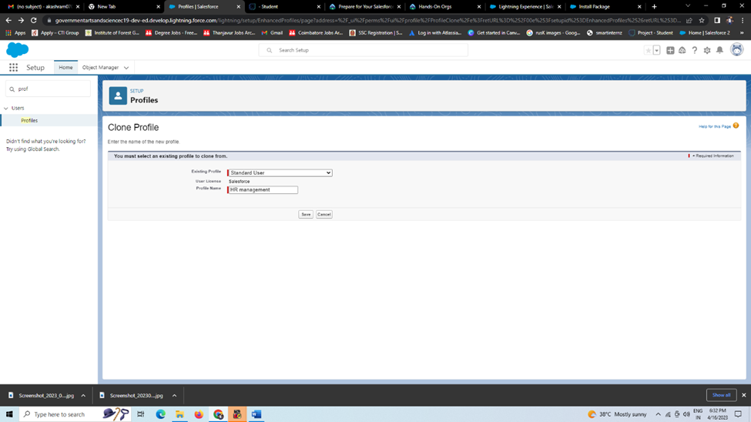

Milestone 10:

Creating a user :

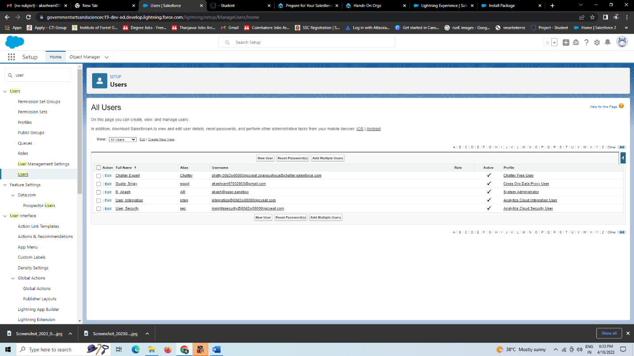

Milestone 11:

Creating a permission set:

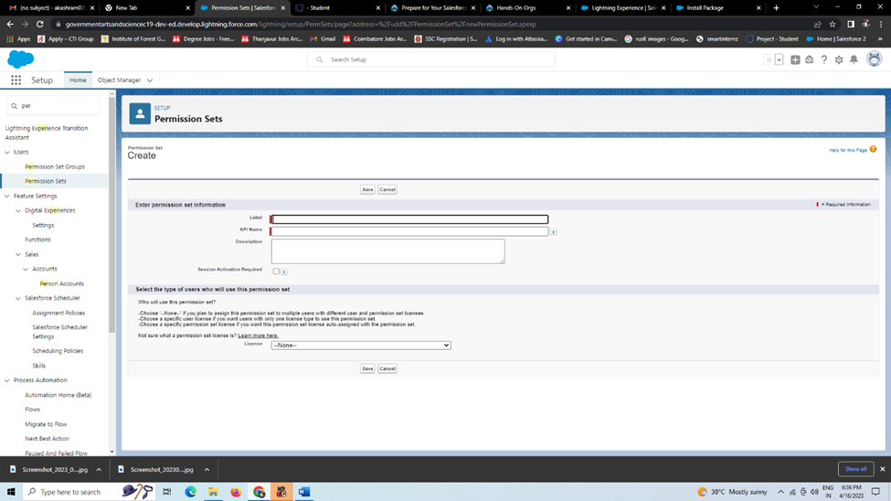

Milestone 12:

REPORTS:

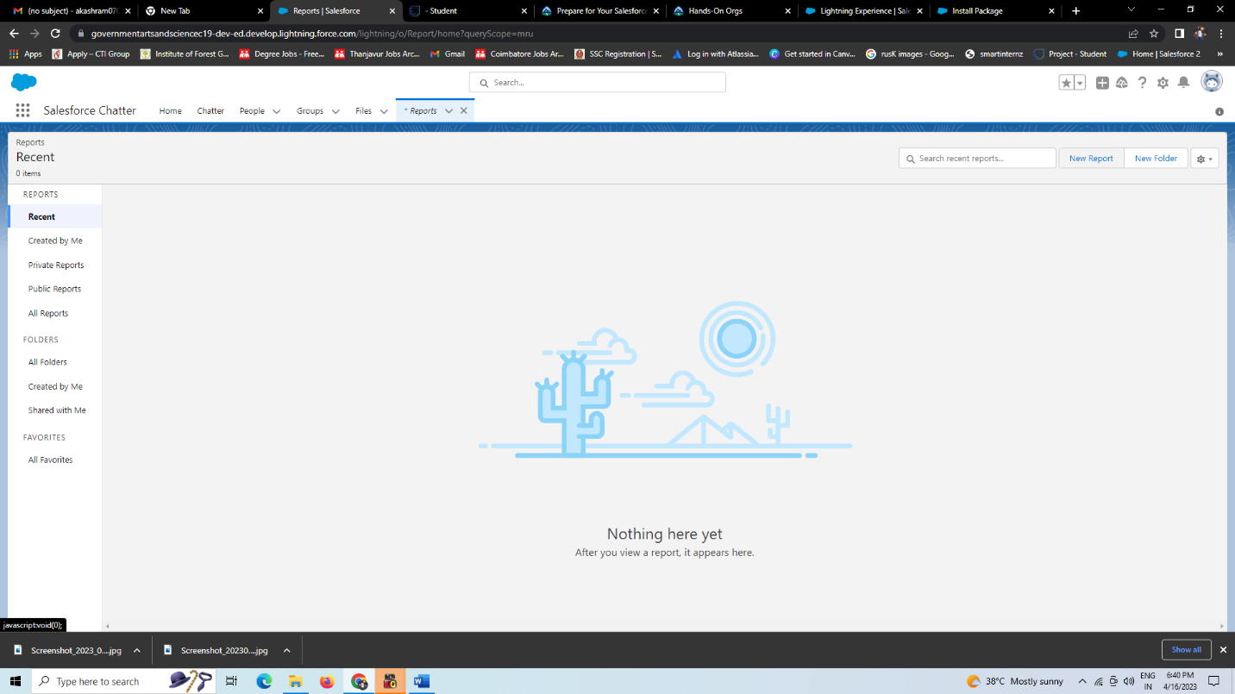

1. Trailhead profile public URL

Team Lead : <https://trailblazer.me/id/akasr15>

Team Member 1:<https://trailblazer.me/id/ssree432>

Team Member 2:<https://trailblazer.me/id/pavithra432>

Team Member 3:<https://trailblazer.me/id/shars282>

Team Member 4:<https://trailblazer.me/id/harinitha1234>

1. ADVANTAGES & DISADVANDAGE

Advantages:

1. A cooperated team work

2. Value for time

3. increasing confidence on HR management

Disadvantage:

1. Affects leadership,

2. Some steps are Stagnant and empty,

3. Lacking more time for not-working milestone (Example: milestone 2- package installation, milestone 7-package layout)